# 3)a PROGRAM

%option noyywrap

%{

#include<stdio.h>

%}

%%

[a-z]*a{3}[a-z]* {

}

.* {

printf("Valid-Accepted");

printf("Invalid-Rejected");

}

%%

int main()

{

yylex(); return 0;

}

# OUTPUT

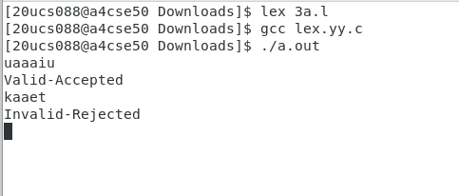

**3)b PROGRAM**

%option noyywrap

%{

#include<stdio.h> int w=0,c=0,l=0;

%}

%%

" " {

}

\n {

}

. {

}

%%

int main()

{

w++;

l++; w++;

c++;

yyin=fopen("3b.txt","r"); yylex();

printf("word:%d\tlines:%d\tcharacter:%d\n",w,l,c); return 0;

}

# 3b.txt

Hi

Nice to meet you Have a great day

# OUTPUT

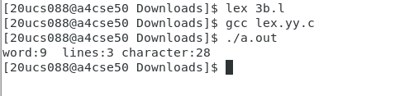

**3)c PROGRAM**

%option noyywrap

%{

#include<stdio.h>

%}

%%

[A-Z][a-z]+ {

}

[0-9]{10} {

}

printf("Valid-Name");

printf("Valid-MobileNumber");

[a-z]+@[a-z]+\.[a-z]+{

}

.* {

printf("Valid-EmailAddress");

printf("Invalid-Data");

}

%%

int main()

{

yyin=fopen("3c.txt","r"); yylex();

return 0;

}

**3c.txt** Ganeshan 9587563456

1234567

[ganesh@email.com](mailto:ganesh@email.com) ganesh.com

# OUTPUT

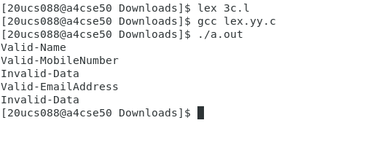

**3)d PROGRAM**

%option noyywrap

%{

#include<stdio.h>

%}

%%

"int"|"float"|"return" {

}

";" {

printf("%s-Keyword",yytext);

printf("%s-Special symbol",yytext);

}

"+"|"=" {

} "{"|"}"|"("|")" {

printf("%s-Operator",yytext);

printf("%s-Bracket",yytext);

}

[a-z]+[0-9]*_* {

}

[0-9]+ {

printf("%s-Identifier",yytext);

}

%%

int main()

{

printf("%s-Constant",yytext);

}

**3d.txt** int main (

)

{

return 0

;

}

yyin=fopen("3d.txt","r"); yylex();

return 0;

# OUTPUT

